Tab 1

### Contract Processing Steps *(Implementation/Success to fill)*

1. Scroll to the Section in a contract called **TIFIN AG ORDER FORM**

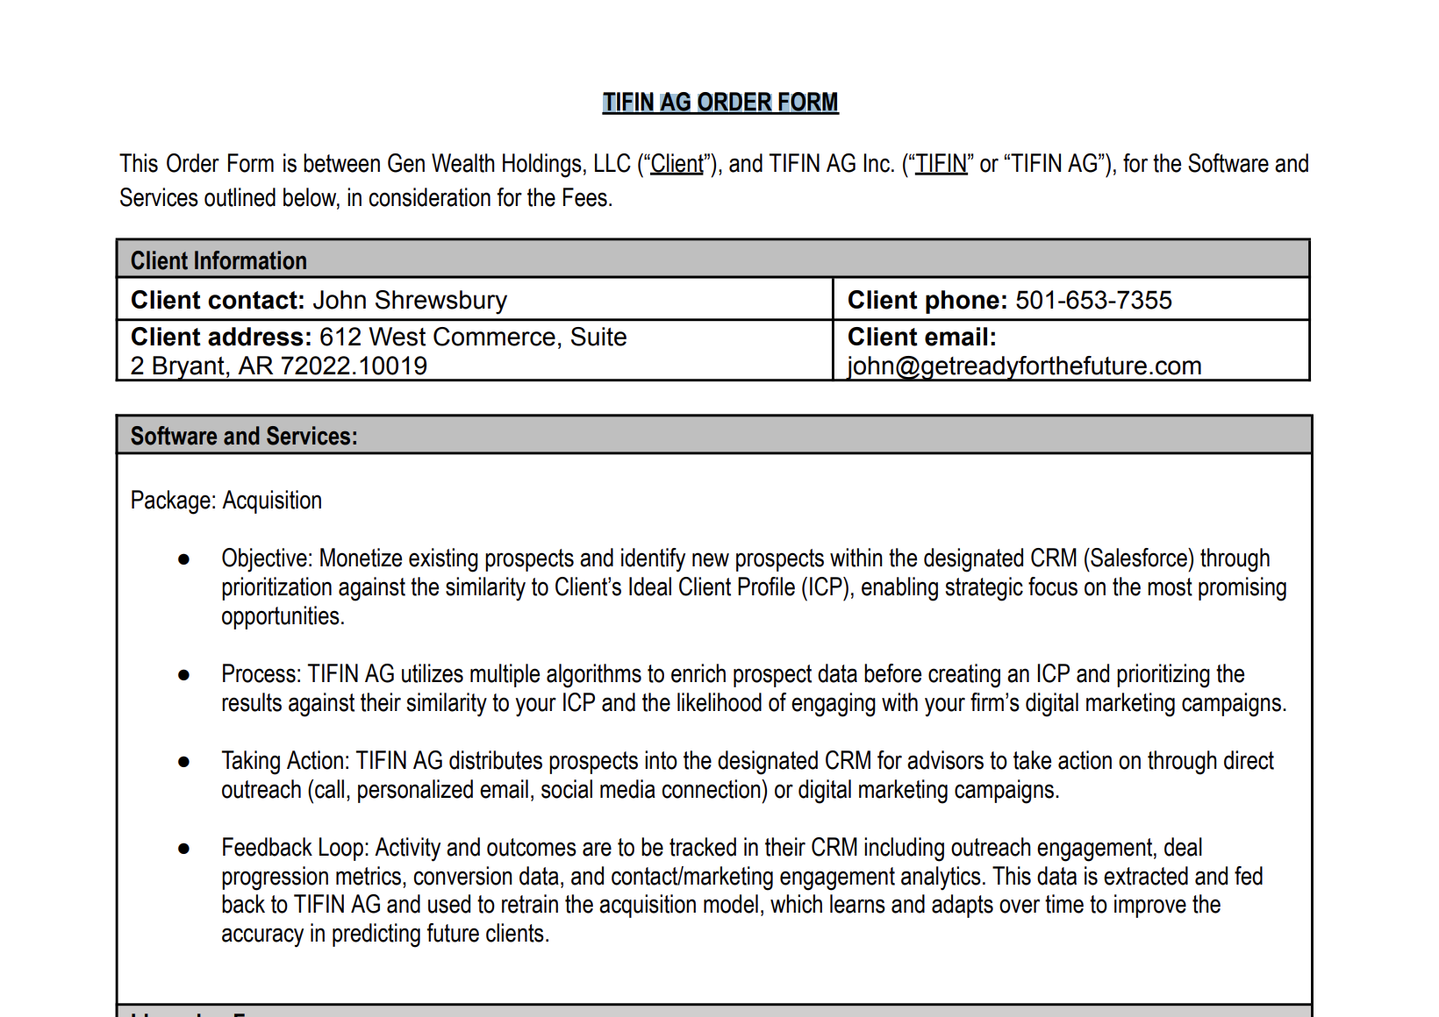it will look like this screenshot here

1. You will see two types of pricing
   1. Full payment

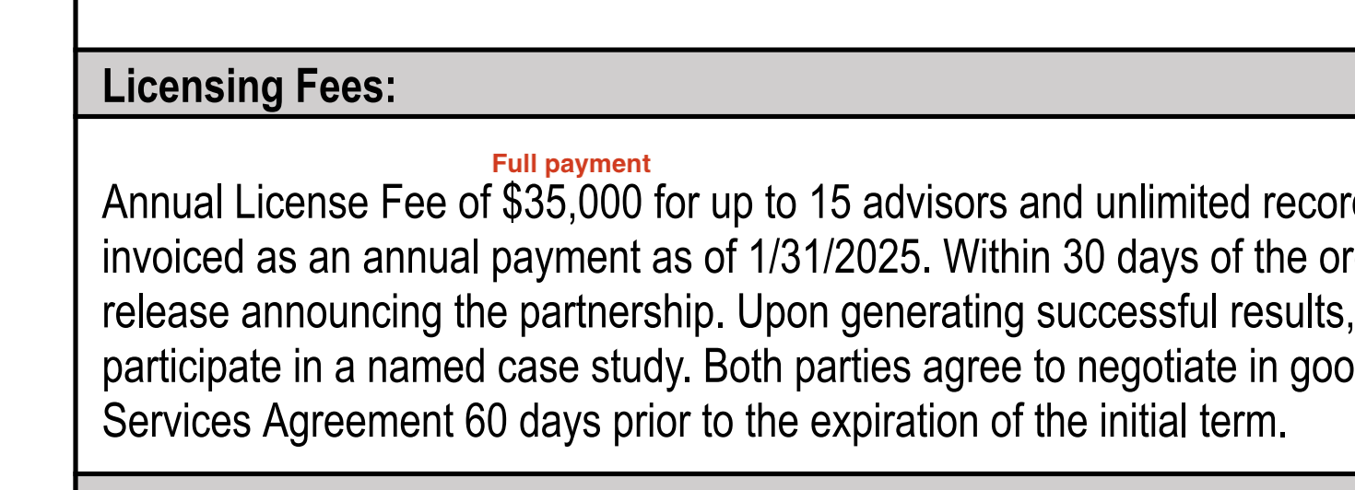

* 1. Payment is split up into payment schedules

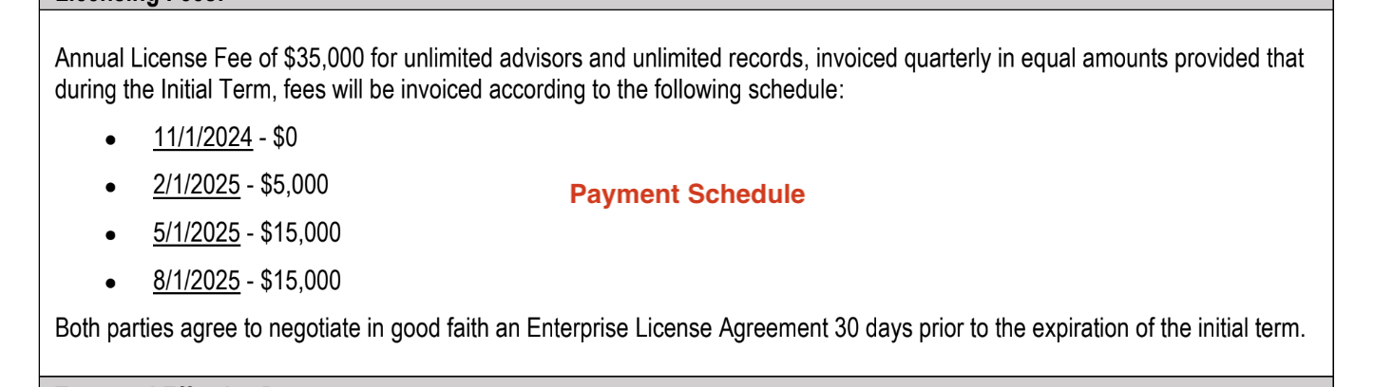

Please find the section below accordingly to process labeled **Full Payment or Payment Schedule**

#### **Full Payment (see screenshot below as example)**

#### 

**Service Start Date:** Invoice Date, not Order Effective Date

**Months of Service:** 36 months

**Item Name:** Annual License Fee

**Item Description:**

**Integration Item:** [**TIFIN Netsuite Integration Items**](https://docs.google.com/spreadsheets/d/1fAQ1rHf_buFcowql7ONgAj6gY01wd3u6nwM4ZAUxqhY/edit?gid=515133391#gid=515133391) **found here**

**Billing type:** Flat **Total Price:** Found in contract

**Quantity:** 1 **Start Date:** Same as service start date **Periods:** default to 3

**Frequency:** 1 year unless otherwise noted  **Net Terms:** Default 30

1. Anything to ignore in contracts?
   1. Order Form Effective Date
   2. Initial Term
2. Specifics processing things the merchant has requested that may differ by contract (e.g. always back-date invoice date to final day of the month)
3. Default Service Term
   1. Default 3 Years
4. Default Net Payment Terms
   1. Default 30
5. Default Billing Frequency
   1. If None Listed, Ops Default is Monthly
6. How do we handle taxes as a line item?
   1. If None Listed, Ops Default is every tax line item becomes a BT

#### **Payment split into payment schedules (see screenshot below as example)**

#### 

Create a Revenue Schedule for every line listed.

**Service Start Date:** Order Effective Date

**Months of Service:** Listed in contract, default 12 if none listed

**Item Name:** License Fee

**Item Description:**

**Integration Item:** [**TIFIN Netsuite Integration Items**](https://docs.google.com/spreadsheets/d/1fAQ1rHf_buFcowql7ONgAj6gY01wd3u6nwM4ZAUxqhY/edit?gid=515133391#gid=515133391)

**Billing type:** Flat **Total Price:** Found in contract, create a revenue schedule for each line item

**Quantity:** 1 **Start Date:** Found in contract, individual to each line

**Periods:** NONE

**Frequency:** NONE **Net Terms:** Default 30

1. Anything to ignore in contracts?
   1. The full amount of license fee
2. Specifics processing things the merchant has requested that may differ by contract (e.g. always back-date invoice date to final day of the month)
3. Default Service Term
   1. 1 year
4. Default Net Payment Terms
   1. Default 30
5. Default Billing Frequency
   1. If None Listed, Ops Default is Monthly
6. How do we handle taxes as a line item?
   1. If None Listed, Ops Default is every tax line item becomes a BT